Colour
Dark1 on Light2
Dark1 on Light1
Light1 on Dark2
Light1 on Dark1

Dark2 on Light1
Dark2 on Light2
Light2 on Dark1
Light2 on Dark2

Accent1
Accent2
Accent3
3

Typography
Fonts
We use two fonts specified in the Microsoft Word Font Theme for headers and body text. The exception is the use of fixed width fonts for some technical documentation styles.
Scale
For the typographic scale we try the system introduced by IBM as part of their carbon design system http://carbondesignsystem.com/style/typography/overview This gives us the body copy at 12 point, introductory text at 14px and then heading 5-1 at 14, 16, 18, 20 and 24 point. The largest piece of text is the chapter heading at 28 point. The following sections shows heading and body copy
Body Copy
If we want the first paragraph to stand out from the rest of the test we use the intro style from the Styles collection. This paragraph has been styled with the intro style and we hope it draws the reader into our wonderful document.
After the introductory paragraph we switch to a normal paragraph format. Where we have multiple paragraphs, we separate them with a decent space to aid readability. Notice now we have a paragraph separation
Now we have a second paragraph separated from the first one. Inside any paragraph we can emphasize text using strong or emphasis styles

Headings
- Chapter Heading

Heading One

Heading Two

Heading Three

Heading Four

Heading Five

Titles, sub-title and introductory section

Document Title

Creating object graphs using Xml
This Document Contains
Creating object graphs
Different kinds of XML elements and attributes

If we want the first paragraph to stand out from the rest of the test we use the intro style from the Styles collection. This paragraph has been styled with the intro style and we hope it draws the reader into our wonderful document.
- List bullet
Captions
We have several kinds of caption. When writing technical documentation once of the most important is the Code Listing Caption
Code Listing
Listing 1 A Code Listing
Diagrams or figures also need a caption and for this we use the following style
Figure1 A Figure
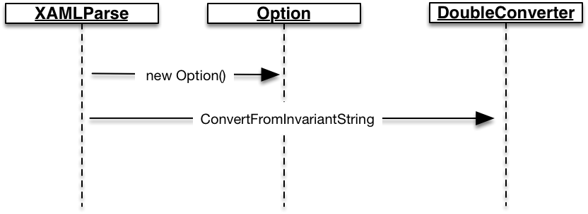
Lists
Bulleted headers use the style List Bullet and may be headed by a heading using the List Bullet Header style.
Disadvantages of multi-threaded programming
- Item One
- Item Two
List Bullet Header
- List Bullet Style
- List Bullet Style
- List Bullet Style
Then in addition to bulleted lists we also support the numbered list
Numbered list header
- List Number Style
- List Number Style

Quotes
Call Outs
TypeConverter versus ValueConverter
It is important to distinguish between TypeConverter and ValueConverter types. One is used in one place and the other is used in the other

Tables
Column Header Table
Table Header
Property | Value
First Value | Second Value
Second Value | Second Value

Row and Column Header Table
 | Column Header
Row Header Lone | Norma Table Cell
Row Header Two

Numbered Description Table
Object Element | Specified to the XAML that an instance of the given type is to be instantiated and added to the object graph
Property Attribute | Specify to the XAML that the named attribute on the instantiated element is to be set using the attributes value

Question and Answer Section Formatting

Questions

Question (sub) section

Sub section 2
Question
Answer
What does a question in Anki look like
Question
Esoteric Question

Source code and Technology
Commands
Often when writing technology documentation, we want to instruct the user to carry out commands. We do this using the following Command Style
git stash
If we want to show the result of a command, we use the Command Output style
Untracked files:
(use "git add <file>..." to include in what will be committed)

hello.txt

nothing added to commit but untracked files present (use "git add" to track)

Commands
Source code listing use the style source code as follows.
public class Option
{
public string Id { get; set; }

public double Strike { get; set; }

public Expiry Expiry { get; set; }
}

If we want to emphasis a particular part of a source code listing we use the source code strong style.

public class Expiry
{
public int Days { get; set; }
}

Keyword

Files
If we want to style a file name we use the Path Style
String.cs

Tutorial
- Step One
- Step Two
Some text here

Appendices
Appendice Section

Appendice

ToDo

ToDo Section
ToDo Que

Coding Examples
Coding Example Heading
Code Example Code
Code Example Diagram
Code Example Runtime
Listing 1C# Option Type

ToDo Section
ToDo Que

Coding Examples
AutoResetEvent e = new AutoResetEvent(initialState: false);

Action work = () =>
{
// Simulate some work this thread is doing
Thread.Sleep(1000);
logger.Info($"Calling WaitOne");

// Now wait for notification from another thread
// that we can complete
e.WaitOne();

// Simulate some more work
logger.Info("Running");
Thread.Sleep(5000);
};

Coding Example Heading

Coding Example Heading

